BDSC 340.401 (On-Line) – Operations Management Fall 2018
Assignment 9
Instructions:
a) Show all the steps followed to arrive at the answer.

1. A.11,
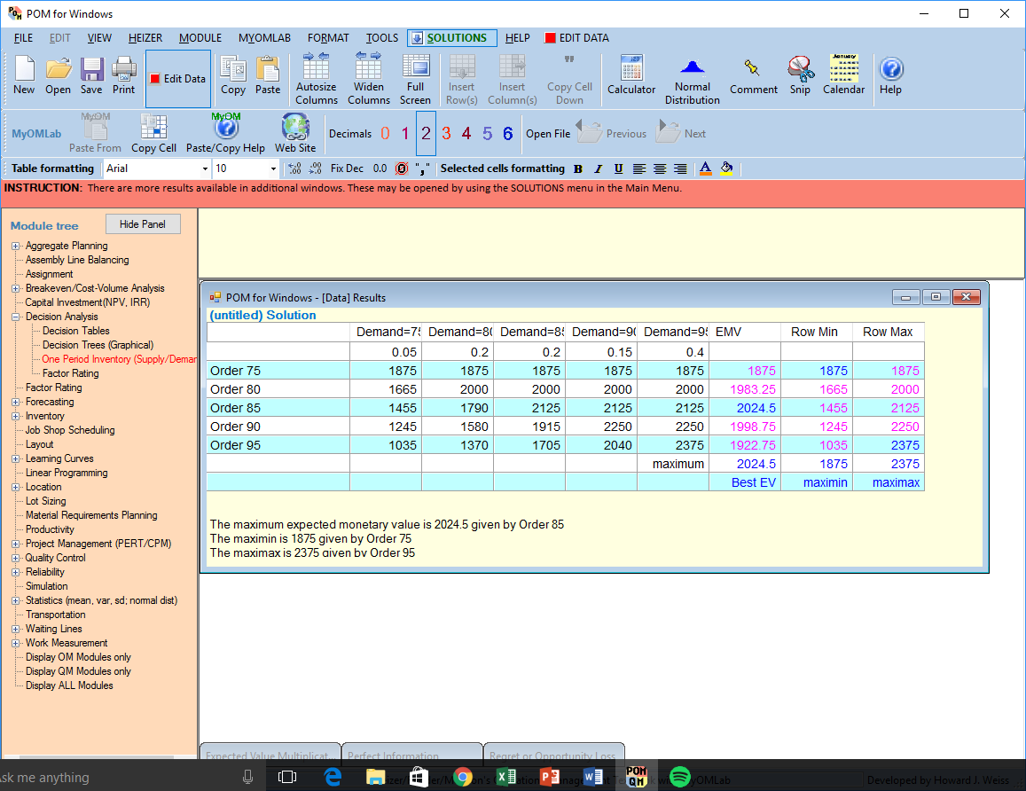
The number of copies that the bookstore should stock to achieve maximum expected value is 85 copies. The EMV of stocking this number of copies is $2025

2. A.13

Probabilities which are associated with the states of nature are
0.25 for a large crowd,
0.50 for an average crowd,
0.25 for a small crowd.
- The alternative that provides Deborah the greatest expected monetary value EMV is Large Inventory.
The EMV for this decision is $11,750
- For Deborah, the expected value of perfect information (EVPI) =$1,500

3. A.15.
States of Nature
Alternatives | Very Favorable Market | Average Market | Unfavorable Market
Large Plant | $275,000 | $100,000 | -$150,000
Small Plant | $200,000 | $60,000 | -$10,000
Overtime | $100,000 | $40,000 | -$1,000
Do Nothing | $0 | $0 | $0

The appropriate Alternative is to use the small plant, with an EMV =$83,333

